**Marketing**

For the advertisement of our product we would be using Influencer Marketing, google ads,

**Influencer Marketing**

Even though a number of companies use google ads for product marketing, but with the rise is AdBlock applications the effectiveness of such advertisements has dropped significantly. An AdBlock is a browser extension which allows users to prevent page elements like ads, from being displayed. Moreover, the use of AdBlock is expected to rise 30% year by year which makes a further dent in the ROI for google ads.

Influencer Marketing is much better option because for every dollar we spent on influencer marketing, statistics show that we get an average of 23 dollar ROI (Return on Investment). In terms of Indian Rupees, for every 1 Rupee spent returns an average of 23 rupees.

The steps we would be following in this approach are as follows –

1. Finding the right influencers
2. Reaching out
3. Pitching the product
4. Deciding the compensation

**Finding the right influencers**

For this part we would be using two methods. First, is simply googling the targeted keywords, which are “gardening”, “hydroponics”. The second method is doing an influencer search on Buzzsumo. This gives a customized list of individuals based on the searched keywords, here “Hydroponics”. The list contains the names, contact information and even a list of their social media accounts and websites. Another platform that can be used for influencer search is Hypr. Along with the other basic information they also provide a readymade look into the specifics of the influencers audience as well as the total engagement and activity on their profile.

These insights into an influencers profile are necessary as, the more we know about them the more we can fine tune our pitch that will hook them on our idea.

We would not be using high-profile influencers but instead, would be using micro-influencers for our promotions as, firstly, as a start-up we do not have the required capital for compensating these influencing giants and secondly, according to Markerly a large number of followers doesn’t mean high activity. They placed the “sweet spot” for comment activity and following between 10k – 100k. The goal is to reach the targeted audience of gardening hobbyist, home growers and professionals who show great interest in new agricultural techniques and also invest in such technology.

The advantage of using micro-influencers lies in the increased chances of conversions, i.e. there is a higher chance of a website visitor ending up in buying our product. According to ExpertVoice, micro-influencers achieved 22.2 times more conversations than average when they recommended products to their audience. They also found that 82% of consumers were more likely to follow a recommendation given by a micro-influencer.

**Reaching Out**

Our main method of reaching out would be via a direct email to the targeted influencers. If the emails go un-responded we would be sending follow-up emails and would also reach out to them on other platforms.

**Pitching the Product**

**Compensation**

Most influencers prefer monetary compensation instead of some exclusive service or extra exposure.

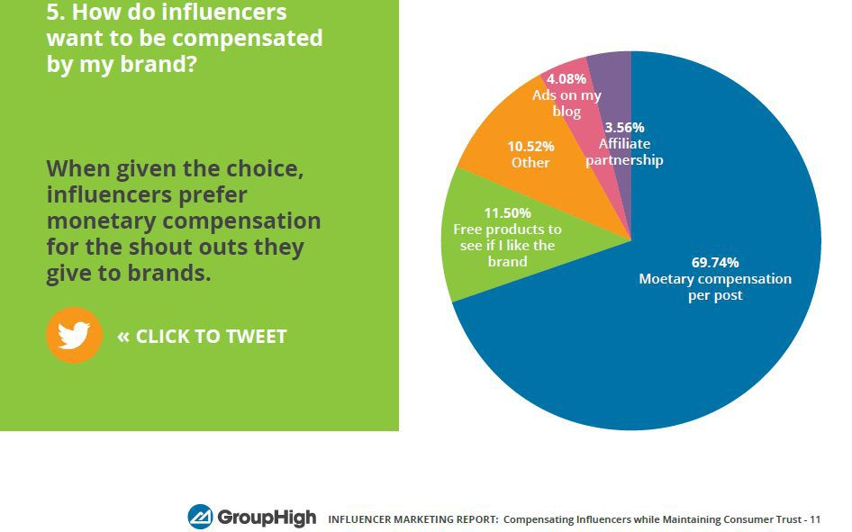

Because we are a new start-up other forms of compensations like shout-outs, free products or accessories would not be viable. So we would be using commission based compensation in which the influencer would be given a certain percentage of the sales procured by them. The starting commission would be decided based on the influencer outreach.

**SEO**

Since, we would be making a website for our start-up on which would showcase our product, SEO (Search Engine Optimization) is a must, which would highly increase the discoverability and ranking of our website.

One of the greatest advantage of using SEO is of it being an inbound marketing strategy i.e. instead of going after your audience with various advertisements and other marketing means, your audience comes to you via their own effort i.e. googling. This process is much more convenient to the customers as they do it with their own accord and at the same time also increases qualified leads for the business. Moreover, according to HubSpot’s most recent State of Inbound report, 59% of marketers said that inbound practices provided the highest quality leads for their sales teams.

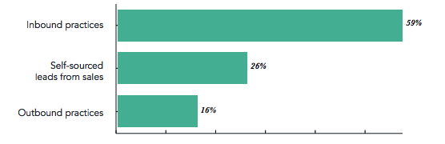

Other advantages include – more clicks than PPC (Pay-Per-Click) ads and no need to pay for any ads.

The process for SEO is very simple –

1. *We learn about what the customers are searching for* – We search for all the possible terms (keywords) a person can search to reach to a product similar to ours, for example “Hydroponic Systems for home”. Various online tools are used to obtain more data on the most used keywords both direct and indirect which are then ranked accordingly.
2. *Creating the page that is optimized for search* – The above process provides the required guidelines about keyword usage, necessary for a more reachable website.

**Viral Marketing**

The idea behind viral marketing is to create such a unique content (post, video or something else) which would spread from person to person at a great speed (like a virus) via social media and, it is the users themselves who spread this content. The most widespread example in recent times is the creation of emotional, surprising, funny or unique videos on YouTube, which are then shared on Facebook, Twitter and other channels.

The process for this type of marketing is very simple, create content that is very attractive to the targeted audience an then post it on the internet and promote it. Here, the content we will be creating would be related to our product i.e. the hydroponic pod.

We would be using the *concealed* dispersion strategy, i.e. the user does not know till the very end that he/she is watching an advertising or branded content. Although this might seem to be deceiving but when blended with a humorous tone has the potential to become viral. One prime example of this is the *Bisleri Mineral Water* advertisement.

The key points while using this method are –

* Finding the right audience – *Which is the gardening, agriculture and tech-savvy community.*
* Choosing the right social platform – *We plan on using Instagram & Facebook because of the sheer number of users and all the advertising tools that are available.*
* Creating high engagement content – *A unique post or short video*
* Timing the content for maximum reach – *This is based on the habits of the targeted audience, like when are they most active and for how long.*
* Boosting visibility with advertising – *Advertising is always helpful in this marketing as it makes it possible to reach other users as well which are outside the targeted community.*
* Partnering with a social media influencer – *Which we already did.*
* Analysing the performance to create better content in the future
* Generating media attention – *When our campaign picks up speed, we would use various media outlets to further amplify it.*
* Sharing novel content – *Originality is key in viral marketing and something new is what catches the users attention.*

The many advantages of this type of marketing are –

* Low expenditure – *There is almost no need to spend money because the content moves forward with the help of users. Only a little capital is required for some advertisements that are needed to provide further momentum.*
* Great reach – *If the content is attractive enough it can easily reach millions of people without any external promotion.*
* Non-invasive – *It is the user who decides whether to share the content or not and therefore does not come across as invasive.*
* It helps in building the brand – *If we create the most interesting and engaging posts while being consistent, users form a personal connection with our brand because of all the past content which we created and the expectation of all the future content that we will make.*